1. until prep. 直到

until now 直到现在

until lunchtime 直到午餐时间

1. outside adv. 外面

inside

upside down 颠倒

1. ring v. （铃，电话等）响

ring rang rung

sing sang sung drink drank drunk

swim swam swum

begin began begun

ring n. 铃响 圈 戒指

Aunt 婶婶 大姨

1. repeat v. 重复

re- retell rewrite

rediscover

重新发现

Rebroadcast

重播

# Lesson 2 单词讲解

一般现在时现在进行时

感叹句

时态？

如何体现？ 一共多少种？

# Lesson 2 课文&语法讲解

一般现在时

谓语 v. = 原形／第三人称单数 （do／does）

I tell you a secret.

He tells you a secret.

Your friend tells you a secret.

一般现在时

谓语 v. = 原形／第三人称单数 （do／does） 用法 1：表示现在经常性习惯性的动作

We have the English class every day. He often gets up late.

always, usually, often, sometimes, never… 一般现在时

谓语 v. = 原形／第三人称单数 （do／does）

用法 2：表示现在的状态

I am a teacher.

We are happy together.

一般现在时

谓语 v. = 原形／第三人称单数 （do／does） 用法 3：表示永恒

The earth is round.

The earth moves around the sun. Practice makes perfect.



一般现在时 变否定／疑问

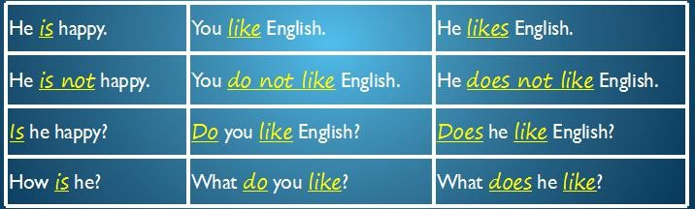

现在进行时

谓语 v. = am／is／are ＋ doing

用法 1：表示现在正在进行的事

可以表示短时间的现在 此时此刻

也可以表示比较广义的 比如第二句

We are studying English now.

J.K. Rowling is writing another book this year.

现在进行时

谓语 v. = am／is／are ＋ doing

用法 2：表示将来确定要发生的事

I am coming to see you.

We are arriving at ....

The old man is dying.

现在进行时 变否定／疑问

He is listening.

He is not listening. Is he listening?

What is he doing?

1. It was Sunday.
2. I never get up early on Sundays.起床早
3. I sometimes stay in bed until lunchtime.

In bed on bed 取决你的床是硬的还是软的，软的陷进去了 就是inbed

1. I looked out of the window.

5.It was dark outside.

1. 'What a day!' I thought.

感叹句：

What + n./n.词组！ How + adj./adv. ! What a wonderful world!

How interesting!

1. 'It's raining again.’
2. Just then, the telephone rang.
3. It was my aunt Lucy.蓝色部分是同位语
4. 'I've just arrived by train,' she said.
5. 'I'm coming to see you.’
6. 'But I'm still having breakfast,' I said. Supper 晚餐
7. 'What are you doing?' she asked.
8. 'I'm having breakfast,' I repeated.
9. 'Dear me,' she said.
10. 'Do you always get up so late?
11. It's one o'clock!'

# Lesson 2 知识拓展

本课重点:

一般现在时 do / does

现在进行时 am / is / are + doing

一般现在时／现在进行时

Right now I’ m in class.

I (sit) am sitting at my desk.

I usually (sit) sit at the same desk in class every day.

一般现在时／现在进行时

Right now I’ m in class. I am sitting at my desk.

I usually sit at the same desk in class every day.

一般现在时／现在进行时

Ali (speak) speaks Arabic.

Arabic is his native language, but right now he (speak) is speaking English.

一般现在时／现在进行时

Ali speaks Arabic.

Arabic is his native language, but right now he is speaking English.

一般现在时／现在进行时

A: (it, rain) a lot in southern California?

B: No. The weather (be) usually warm and sunny.

一般现在时／现在进行时

A: Does it rain a lot in southern California?

B: No. The weather is usually warm and sunny.

一般现在时／现在进行时

A: I’ ll take those- the yellow flowers.

B: Here you are, mister. Are they for a special occasion? A: I (buy) them for my wife.

I (buy) her flowers on the first day of every month.

一般现在时／现在进行时

A: I’ ll take those- the yellow flowers.

B: Here you are, mister. Are they for a special occasion? A: I am buying them for my wife.

I buy her flowers on the first day of every month.

本课重点:

一般现在时 do / does

现在进行时 am / is / are + doing

练习：

我从来不起床那么早在周末

我有时候午餐时间了还在床上

我刚坐火车到这里

